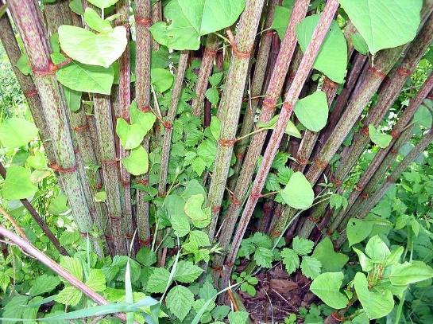
Invasive Species
Japanese Knotweed (Fallopia Japonica)
- Native to Asia
- Introduced in the 1800’s for erosion control
- Mistaken for bamboo
- Aggressive root system: can grow through concrete and asphalt
- Difficult to control after it establishes itself
Consequences of Japanese knotweed
- Spreads easily and quickly
- Creates thickets destroying/limiting wildlife habitats
- Reduces plant biodiversity- makes it difficult for native plants to grow
- Very persistent- ability to survive many different types of weather
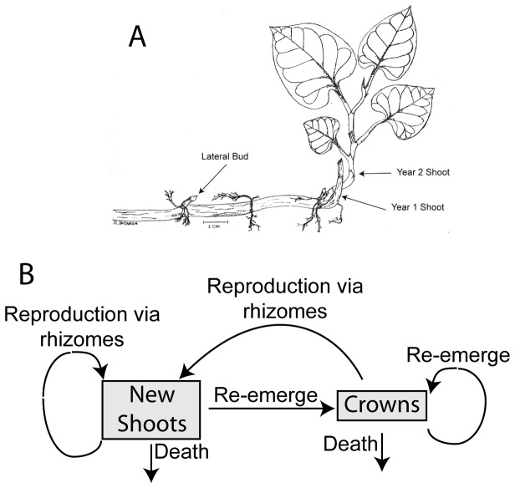
- If grown near rivers/lakes, water may carry a part of the plant to somewhere else and start a new growth
How to identify Japanese knotweed
- 2-3 meters tall
- Dense with lots of foliage
- Stems look like bamboo, when the stems are broken they are hollow inside
- Spade shaped leaves
- August-October: white flowers

Managing Japanese Knotweed
- Remove any Japanese knotweed you see in bunches or by itself, insure that you have dug up the roots as well as the stems and leaves
- After you remove the plant dispose of it safely to ensure no further spread:
- Method one for safe disposal: After you have the entire plant put it in a municipal trash bag and safely seal it. Leave the sealed bag for a few weeks or until the plants are totally dead, dehydrated or rotten. Then put it out with the trash.
- Controlled burning: Where it is legal and safe. Make a bonfire, burn until everything is incinerated. Douse the embers, stomp of them. Then cover the site with dirt and/or sand.
- Smother it: Place a tarp or plastic sheet over the problem area to smother the Japanese Knotweed

Our Plan at Riverstone
Japanese Knot weed is present on the Riverstone property in various places. To control it, we are going to remove the entire plant where possible and seal it into paper leaf bags and wait until it is completely dead before disposing of it to ensure that the plant can’t spread further. Also for larger areas we are going to place a tarp over it and weigh the tarp down to kill the invasive species.
Links and References:

http://www.japaneseknotweedspecialists.com/what-is-japanese-knotweed/
http://www.timberpress.com/blog/2013/05/how-to-dispose-of-invasive-plants/
http://www.londonjapaneseknotweed.co.uk/Burning.html

