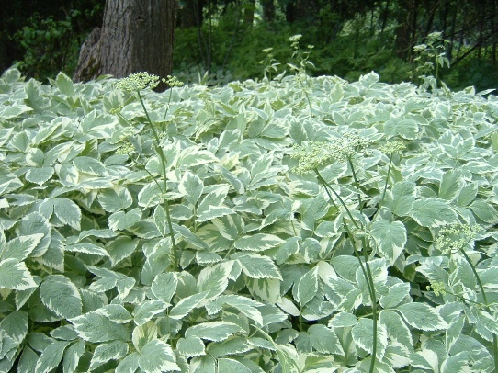
Invasive Species
Goutweed (Aegopodium podagraria L.)
- In the carrot family
- Native to Eurasia
- Introduced as an ornamental plant
- Used as a medicinal herb in medieval times

Consequences of Gout Weed
- Spreads quickly
- Chokes out native plants
- Grows almost anywhere so it is very hard to control and kill
- Grows through grass
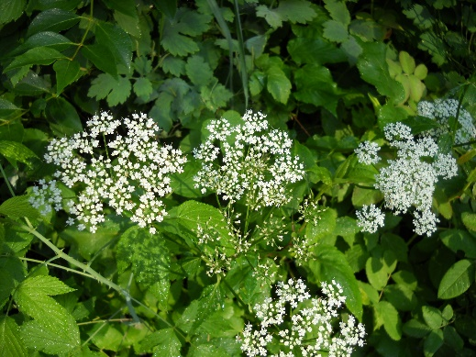
How to identify Goutweed
- Grows about 100cm tall
- Hollow stems
- Toothed leaves
- Green leaves with white around the edges
- Or light green leaves
- White flowers
Managing Goutweed
There a few different methods for managing goutweed if you find it on your property.
- Smother the goutweed
- Cut the goutweed as short as possible
- Place cardboard over the goutweed and past it several feet
- Put a thick layer of mulch on top of the cardboard
- Wait – smothering can take as long as two years
- Spray the goutweed
- Get 20% horticultural vinegar
- Spray all the goutweed- three times over about 1 ½ - 2 months
- Remove all the dead plants and put them in a paper leaf bag, seal it and when it starts to rot put it out with the trash
- “Cook” the goutweed
- Get a sheet of black plastic larger enough to cover the patch of goutweed+ a few extra feet in every direction
- Water the area with the goutweed well
- Place the plastic on top of the goutweed
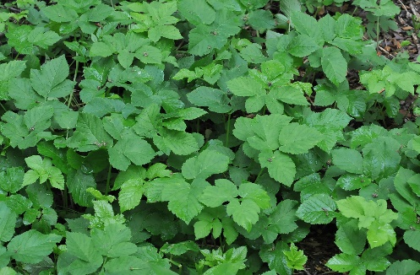
- Bury the edges or put bricks around the edges to lock in the heat (temperature will rise to about 130F and will hopefully kill the goutweed
- Leave for 6-8 weeks
- If you have no growth after a month it is possible that all the goutweed is gone

Our Plan at Riverstone
Goutweed is present on the Riverstone property in several places. On the edge of the property there is a large opening where the goutweed is growing. On this spot, we will “cook” the goutweed, using the method of watering the area and then placing the plastic sheet over it. The other spot where the goutweed is present is along part of a fence. Here we swill spray it, using 20% horticultural vinegar to spray the are 3 times over about a month and a half.

References:
http://vancouversun.com/news/staff-blogs/how-to-kill-weeds-naturally-goutweed
http://savvygardening.com/goutweed/
https://www.amazon.com/dp/B00GB8PS9I?psc=1
https://www.bing.com/images/search?view=detailV2&ccid=uM%2FuHKXp&id=2F819F9412474A297485D2E7D45CA762750316D8&thid=OIP.uM_uHKXpuYSxalvT4kvEywEsDF&q=goutweed&simid=608000734598073222&selectedindex=2&mode=overlay&first=1
https://www.bing.com/images/search?view=detailV2&ccid=iZpv4m2W&id=1150F0F002ABB2D2882ABA87DB5C41BB1124A4FE&thid=OIP.iZpv4m2WjNkn9TUPejPdLgEsDh&q=goutweed&simid=607996770365407373&selectedindex=1&mode=overlay&first=1
https://www.bing.com/images/search?view=detailV2&ccid=C2b0V70T&id=BBEEC8CD35E4A45891E5953390FB3776D3EB6619&thid=OIP.C2b0V70TQkfIG-5p_Jbn3QEgDY&q=goutweed&simid=607998526977411519&mode=overlay&first=1

